**Ex 17-1 # 3:**

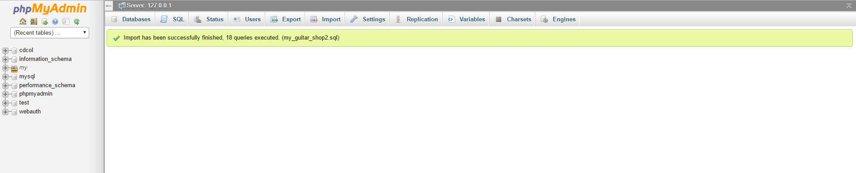

Successfully ececuted my_guitar_shop2.sql by import.

**Ex 17-1 #5:**

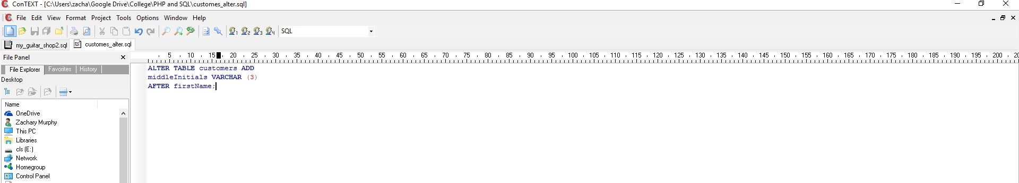

Used ALTER TABLE statement to add columns.

**Ex 17-1 #6:**

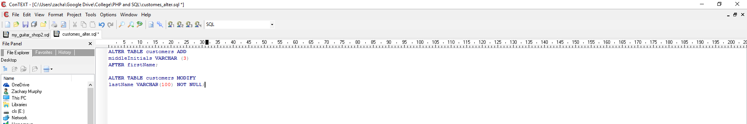

Used ALTER TABLE statement to modify the customers table so the lastName column can store up to 100 characters

**Ex 17-1 #7:**

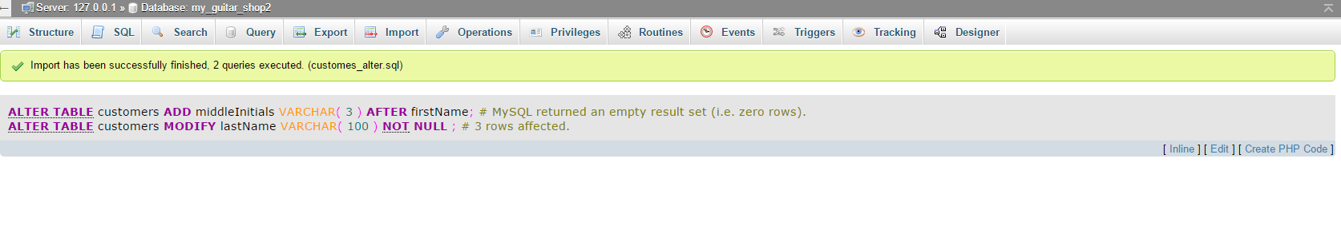

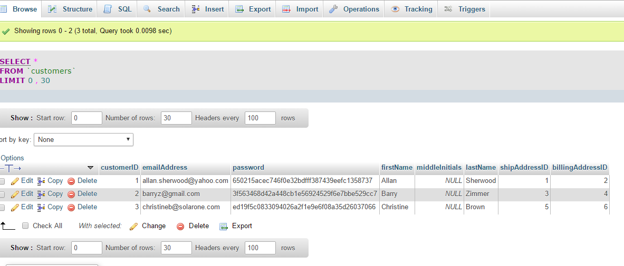

Script seemed to work properly.

**Ex 17-2 #6:**

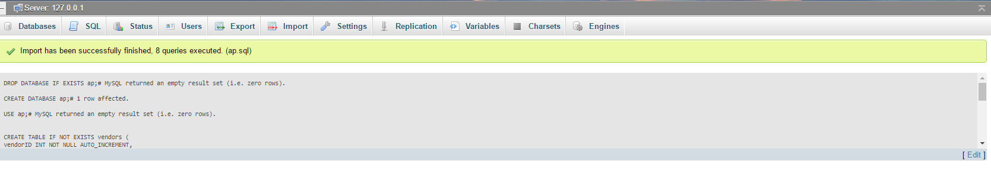

Pulled in script correctly.

**Ex 17-2 #7:**

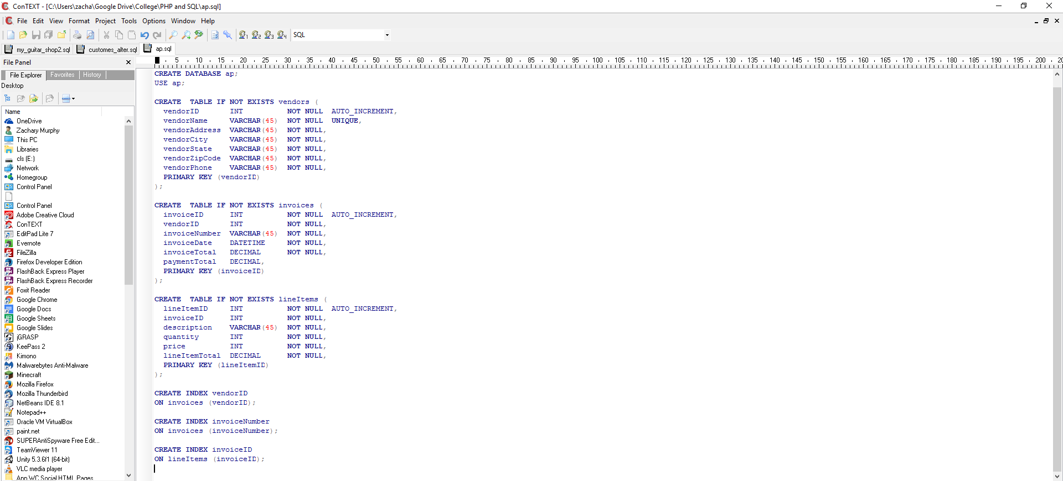

Added CREATE INDEX statements

**Ex 17-2 #9:**

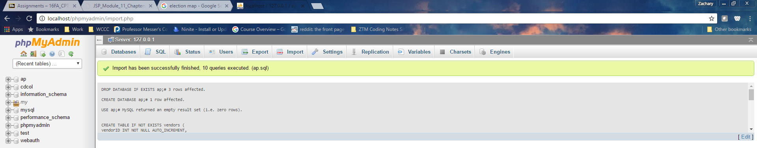

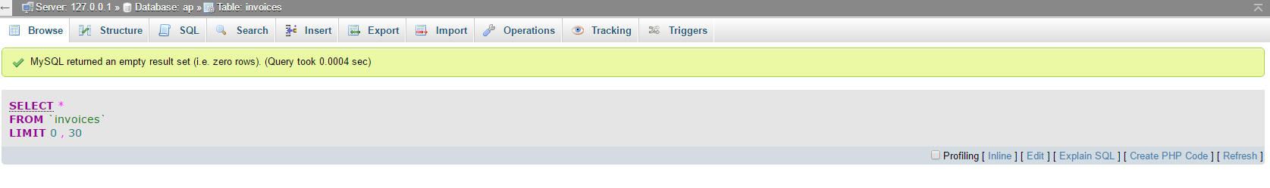

Final product seems to be working fine.